***Lab 2 –Primitive Data Types and Operations***

***Answer the following questions.***

**Use Scanner class for prompting the users for input.**

Instructor-led Demo:

Write a program that reads a number in feet, converts it to meters, and displays the result. One foot is 0.305 meters.

EXERCISE:

1. Write a program that reads a Fahrenheit degree in double, then converts it to Celsius and displays the result on the console. The formula for the conversion is as follows:

celsius = (Fahrenheit – 32) * 5 / 9

**CODE**

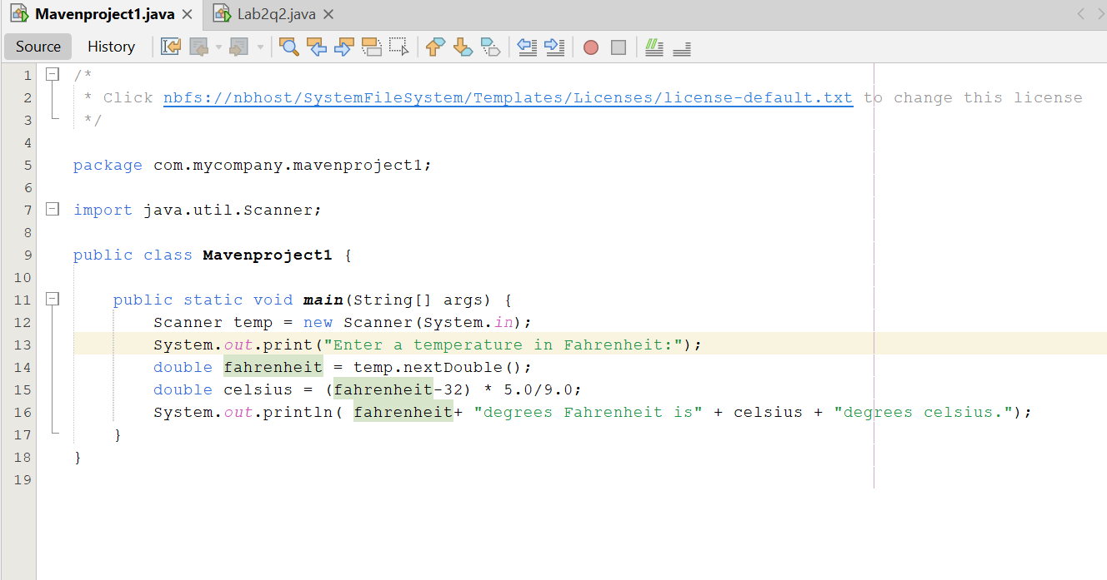

**RESULT**

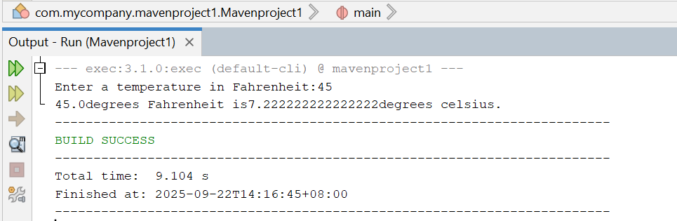

1. Write a program that reads in the radius and length of a cylinder and computes volume using the following formulas:

area = radius * radius * PI

volume = area * length

**CODE**

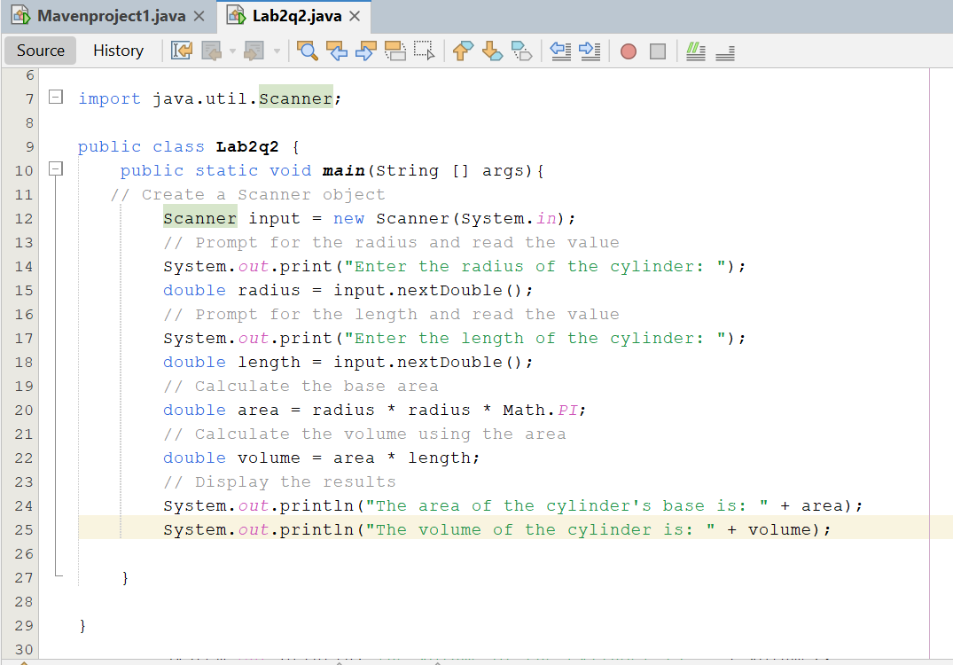

**RESULT**

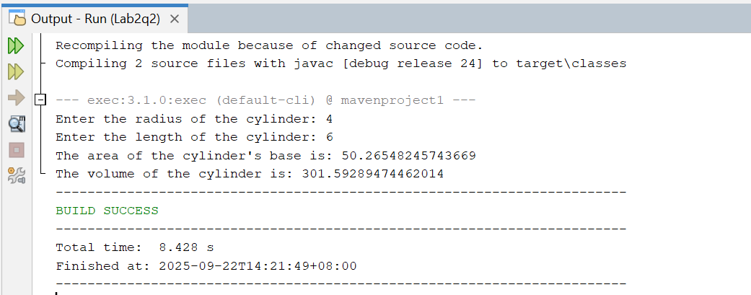

1. Write a program that reads an integer between 0 and 1000 and adds all the digits in the integer. For example, if an integer is 943, the sum of all its digit is 16.

**CODE**

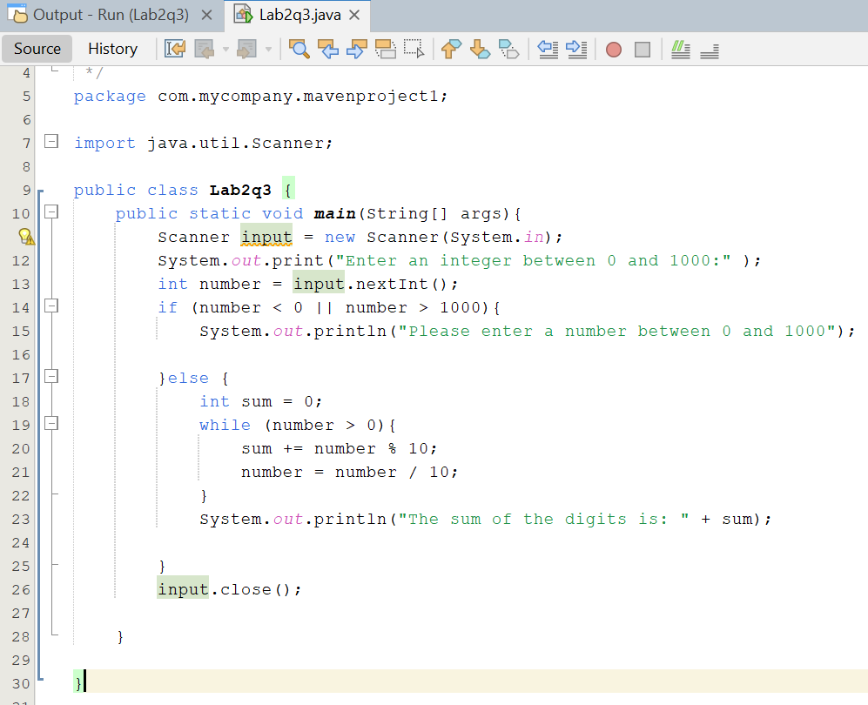

**RESULT**

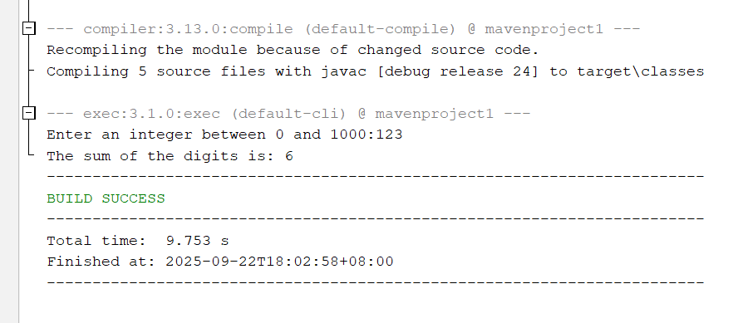

1. Write a program that converts an uppercase letter to a lowercase letter.

**CODE**

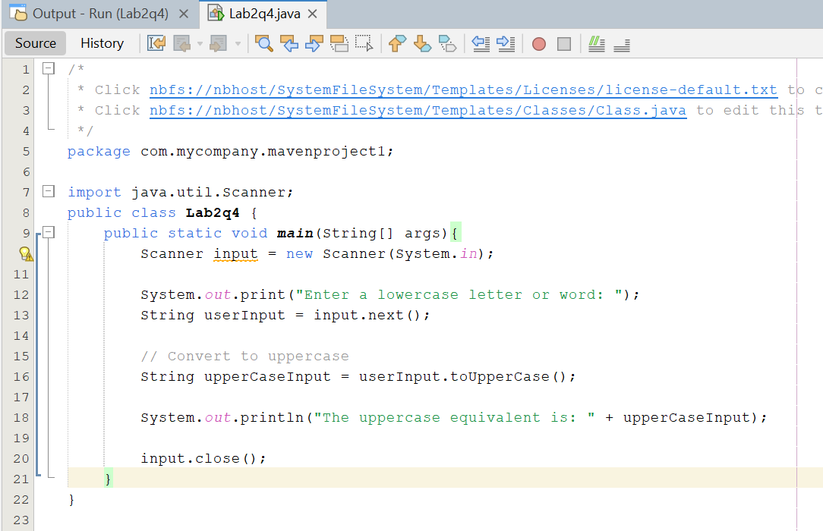

**RESULT**

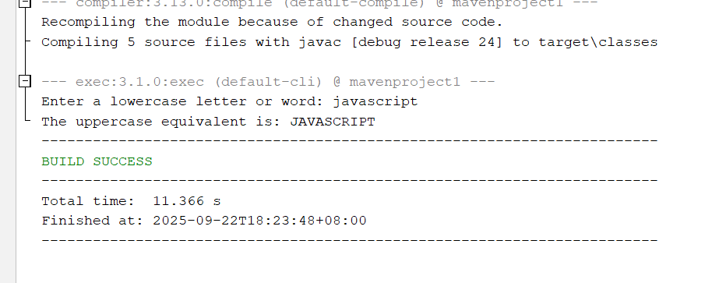

1. Write a program that receives an ASCII code (an integer between 0 and 128) and displays its character. For example, if the user enters 97, the program displays character ‘a’.

**CODE**

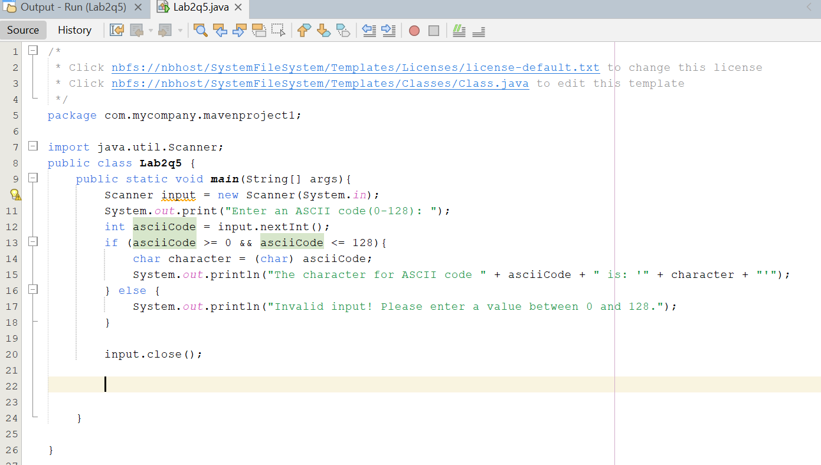

**RESULT**

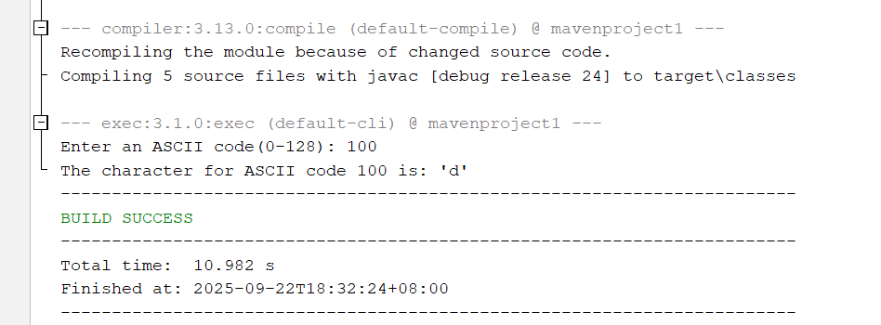

1. Write a program that prompts the user to enter the month and year, and displays the number of days in the month. For example, January is 31 days, February is 28 days, March is 31 and etc.

**CODE** 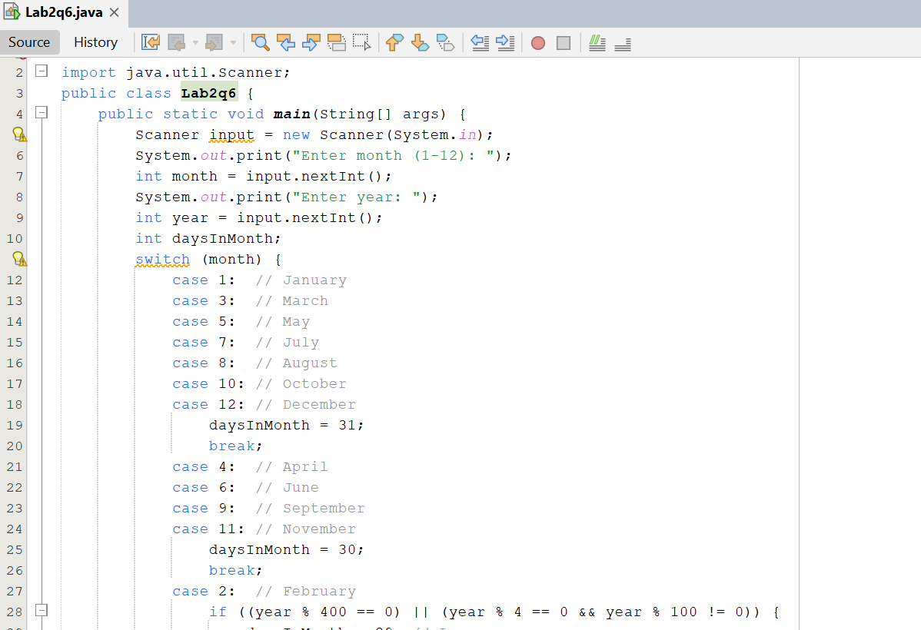

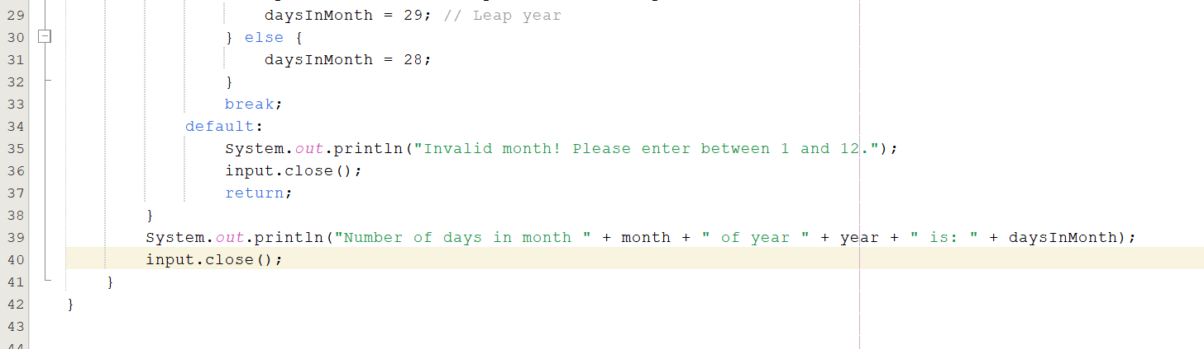

**RESULT**

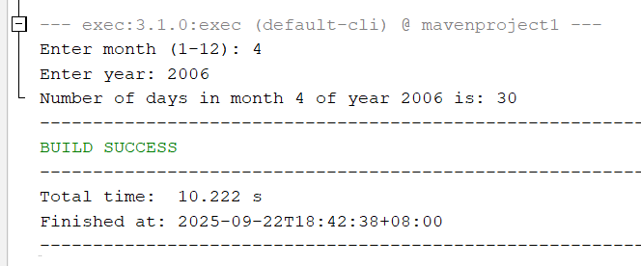

1. Write a program that prompts the user to enter assignment marks and displays the grade of the keyed in marks. The grading table is as follows:

|  |  |  |
| --- | --- | --- |
| **Marks** | **Grade** | **Description** |
| 0-40 | F | Fail |
| 40-49 | F+ | Marginal Fail |
| 50-54 | D | Pass |
| 55-64 | C |
| 65-69 | B | Credit |
| 70-74 | B+ |
| 75-79 | A | Distinction |
| 80-100 | A+ |

**CODE**

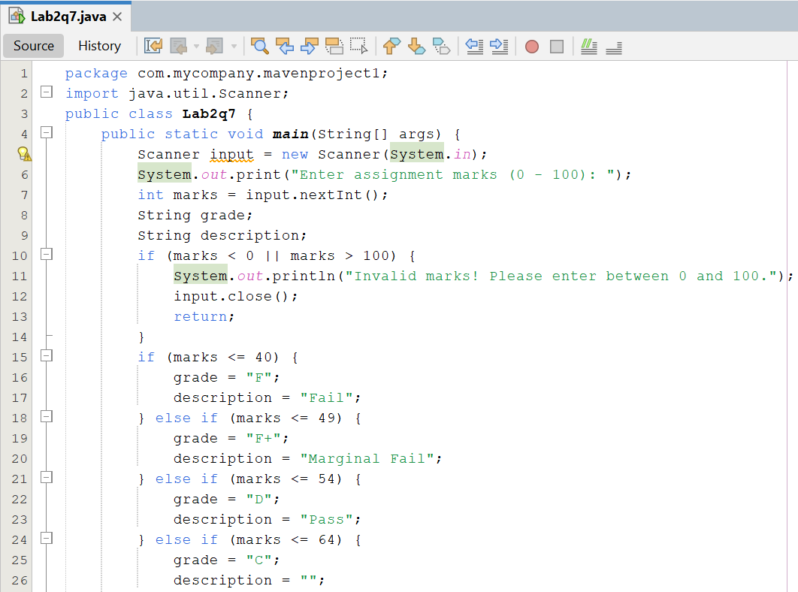

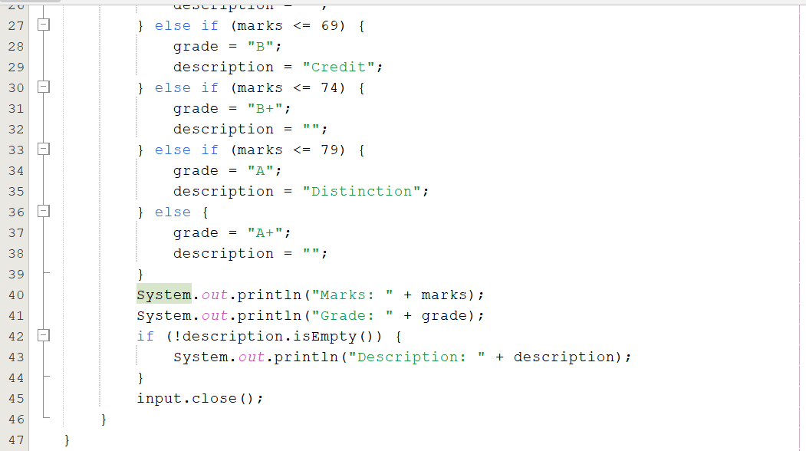

**RESULT**

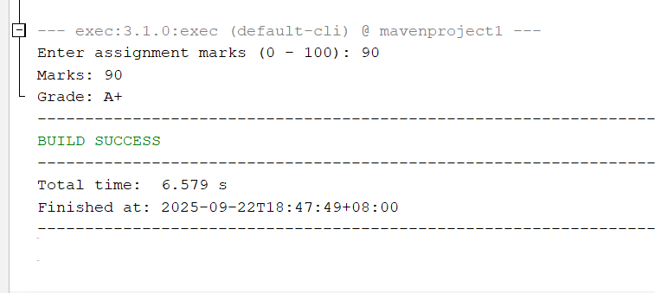

1. Write a program that sum up all the values in double typed of an array. The array capacity is 100. You are required to use for-each construct (enhanced for).

**CODE**

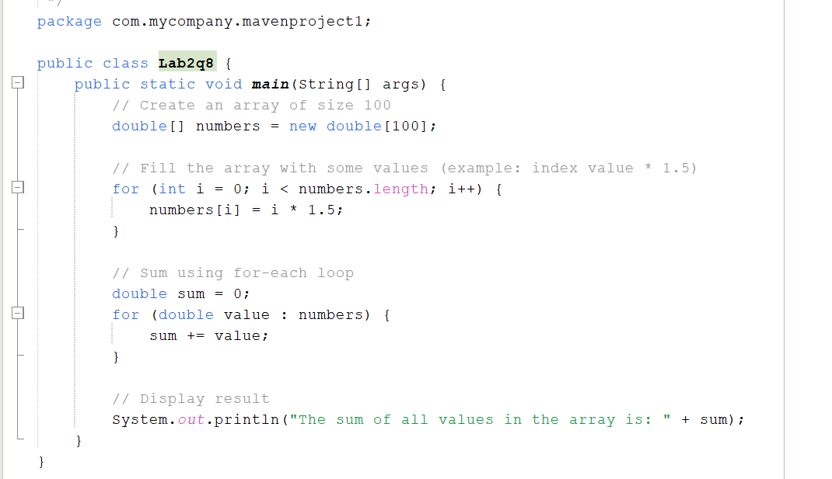

**RESULT**

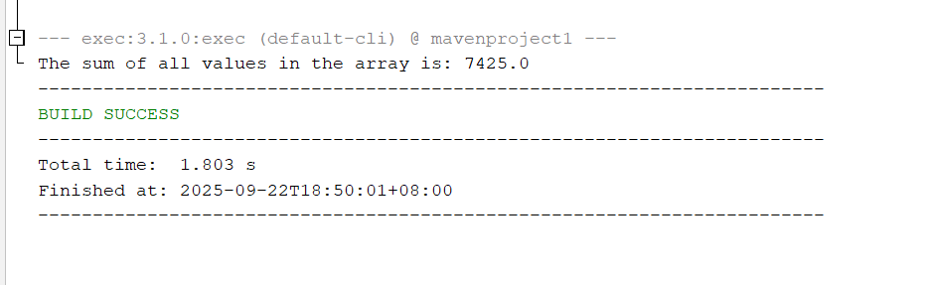

1. Suppose that the tuition of a university is RM10000 this year and this tuition fee increases 5% every year. Write a program that uses a loop to compute the tuition in ten years.

**CODE**

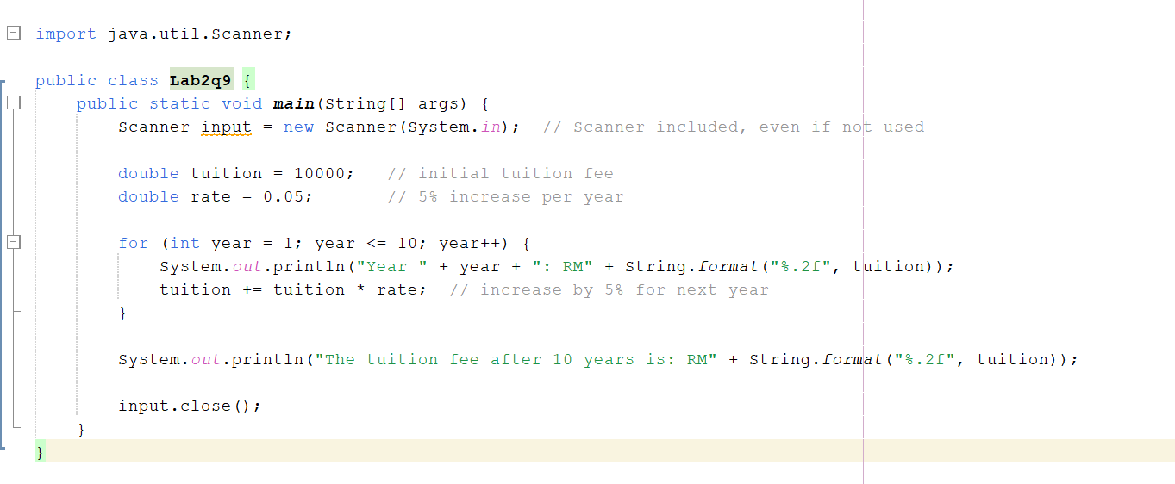

**RESULT**

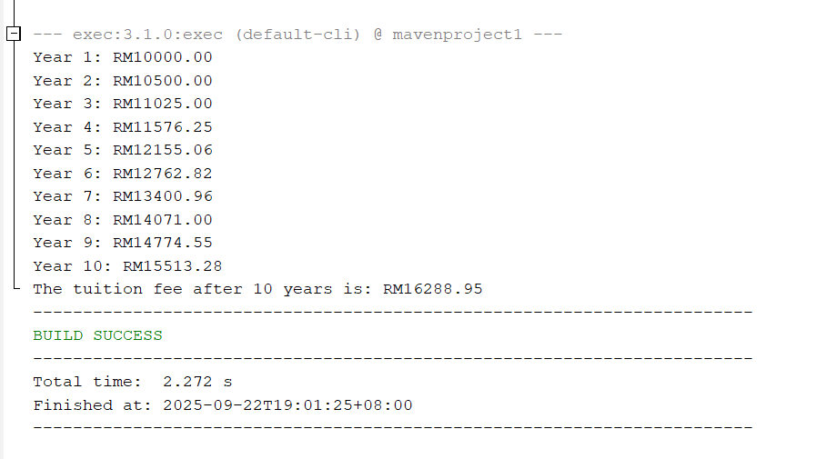

1. Use do-while construct, write a program that prompts the users to continue the program execution. “Yes” to continue the program and “No” to terminate the program.

**CODE**

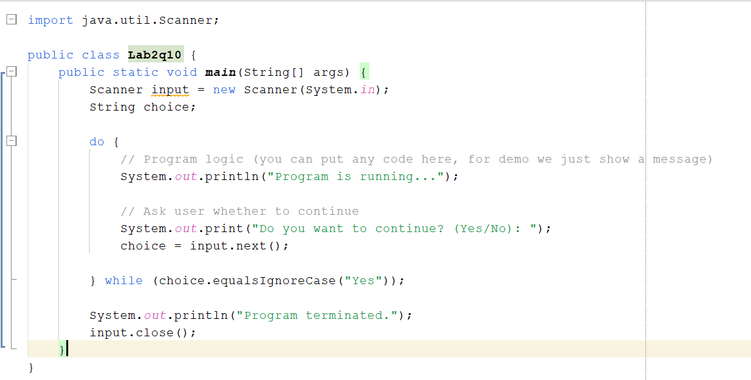

**RESULT**

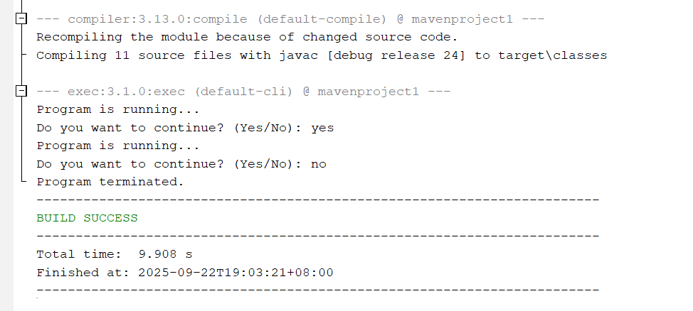

1. Write a program that reads in investment amount, annual interest rate, and number of years, and displays the future investment value using the following formula.

futureInvestmentVal = investmentAmount x (1 + monthlyInterestRate) numberOfYears*12

**CODE**

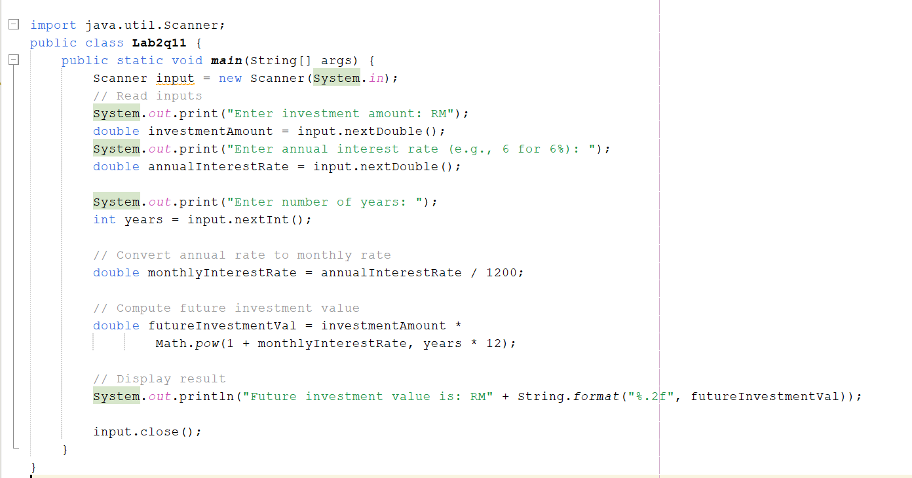

**RESULT**

